Model No. | Description |  |  |  |  | Qty. | Price (Rs.)
TPS-BF-374 | Automatic Four Head Screw Capping Machine |  |  |  |  | 1 | 4,50,000/-
 | 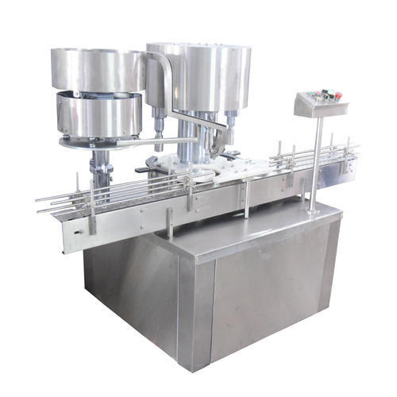
 | Description
 | Automatic Screw cap sealing machine is versatile, self-supported on stainless steel leg with height adjustable adjustment system. The machine is precision built on sturdy welded steel frame completely enclose in stainless steel sheet and doors are provided to facilitate the servicing of machine
 | Operation
 | The feed container moving on conveyor belt are fed into star wheel, bringing the container below the sealing head in the subsequent indexing part, mean while the bottle pick up a cap from the delivery chute of cap feeding bowl, where the body and the neck of the container are positioned below the rotating head, where the sealing head is performing perfect operation of Capping.
 | Technical Specifications
 | Output/Hour* |  |  |  | 3600 to 6000 bottles
 | Direction of Movement |  |  |  | Left to Right
 | No. of Sealing Head |  |  |  | 4 Nos.
 | Power Consumption | Main Motor |  |  | 1.5 HP / 415 Volts / 50 Hz.
 |  | Cap Feeding Bowl |  |  | 300 Watt, Magnetic coil
 | Height of Conveyor |  |  |  | 860 mm to 910 mm
 | Machine Dimensions** |  |  |  | 2135 mm (L) x 1200 mm (W) x 2250 (H) Approx.
 | Case Dimensions |  |  |  | 2650 mm (L) x 1300 mm (W) x 2300 (H) Approx.
 | Net Weight |  |  |  | 950 Kgs. Approx.
 | Gross Weight |  |  |  | 1200kgs.
 | Change parts required |  |  |  | (A) Container: Star Wheel, Back Guide, Feed Worm  (B) Cap Die, Delivery Chute, Bowl
 | Input Specification
 | Screw Cap  Specification |  | Diameter** |  | 19 mm to 38 mm***
 |  |  | Height** |  | 15 to 18.3 mm
 | Container Size** |  | Round Shape |  | Ø 28 mm to Ø 100 mm  Respectively height 58 mm to 240 mm  (Height option for other bottle height available)
 |  |  | Flat / Square |  | 15mm to 100 mm (Length)  Respectively 10mm to 50 mm (Width)  Respectively height 58 mm x 240 mm  (Height option for other bottle height available)
* Depends on bottle size, cap size and type of cap.
** We can supply as per customer requirements.
*** With help of change parts.
 | Salient Features
- No container No cap arrangement.
- SS elegantly matt finished body.
- Single motor synchronizes conveyor, star wheel.
- Adjustable height of conveyor belt, to align with other machine of the line.
- Sealing pressure can be varied to suit different gauges and size of caps.
- Low noise level, low power consumptions.
- Self-lubricating UHMW-PE guide profile for low friction wears surface, smooth and noiseless conveying.
- SS cladding or hard chrome plating of all exposed parts to ensure long life and resistance against corrosion.
- Synchronized A/C drives to synchronize, Conveyor, Star wheel and Platform turret & capping bowl.
- Adjustable bottle height gauge for easy and quick setting.
 | Utility Requirement
 | Electrical supply |  |  | 3 Phase + Neutral + Earthing
 | Electrical load |  |  | 1.5 KW

